**“COSY AIR-CONDITIONERS”**

**“Pel”**

**“Models”**

**“PEL Cool Smile 1 Ton”**

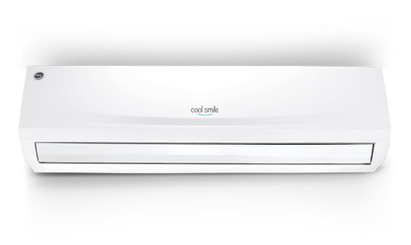

**FEATURES**

* HIGH QUALITY COMPRESSOR
* FULL COOLING WATTS
* FINS CURE
* REVERSE CRYSTALLINE TECHNOLOGY
* ENERGY EFFICIENT
* NEW IHCCD GENERATION

**RS ~ 35000.**

**“PEL Aspire 2 Ton”**

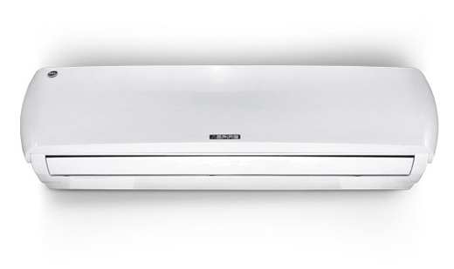

**FEATURES**

* HIGH QUALITY COMPRESSOR
* FULL COOLING WATTS
* FINS CURE
* REVERSE CRYSTALLINE TECHNOLOGY
* ENERGY EFFICIENT
* NEW IHCCD GENERATION

**RS ~ 65,000.**

**“PEL 24KDM”**

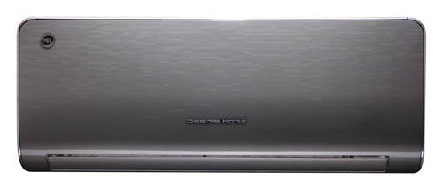

**FEATURES**

* Wall mounted split air conditioner
* Energy efficietnt with high EER
* Auto Restart / Auto Sleep
* Copper Pipe
* Memory Function
* Quiet Design
* Dry Mould Proof
* Multi Fan Speed
* Copper condensor

**RS ~ 65,500.**